Theme  The Romans  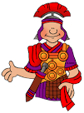  Find five or more facts about The Romans Present your facts in an attractive way such as a poster PowerPoint or writing over a picture. | French  C’est Moi  Draw a picture of yourself and tell me in French:  Your name (Je m’ appelle)  Your age (J’ai ans)  Your eye colour (J’ai les yeaux ………..)  Your hair colour (J’ai les cheveux……..) | Reading  Reading Record  Show you have read each day by recording a comment about the ages you have read.  5 days in a row = a sticker.  How many stickers can you get this half term?
ART  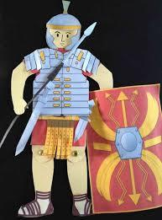  Collect a soldier outline from Miss. Clarke. Using different materials such as tinfoil, cloth, card etc create your own mini Roman Soldier. You could even make a separate mini helmet, shield and boots for him and stick them on as extra accessories. Make it the best you can for our WOW door and display board. | Literacy  Instructions  Write a set of instructions for a game or recipe. You can create the game yourself or explain how to make something you have already. If you follow a recipe try to bring in photos of your dish and even the food for us to try! | R.E  What is Diwali and why is it important?  Using the internet and Powerpoint or Google slides, create an information sheet about Diwali.
Science  Light  What sources of light can you find in magazines and catalogues?  Create a collage. | PSHE  Me and my relationships  Find a picture of you and someone or a pet. What relationship do you have with the person or pet? Why is this person or pet so special to you? | Maths  Addition  The next time you go to the shops, ask an adult if they can keep the receipt. Choose 2 items from the list and add them together. Repeat this another three times. Show your working you for all four calculations. Try to use the methods we have done in class. If you have forgotten please ask Miss Clarke first so that the method you use at home is the same as what you are using in school.

