In History this half term, we will be studying

The Romans

In Maths this half term we will be learning about

Place Value

Addition and Subtraction

Class 3’s Autumn term learning.

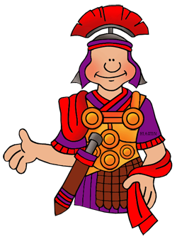

In P.E

Monday- Swimming

Wednesday- York City Football Club

In Literacy this half term we will be learning how to write instructions.

**French**

* ‘TuttiFrutti’ – say, read and write different fruit names and use them successfully in questioning and answering sessions; likes and dislikes
* French songs linked to the topic

In Science we will be learning about Light

…

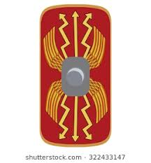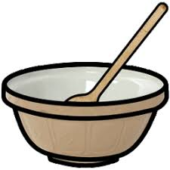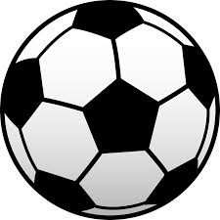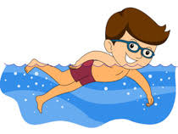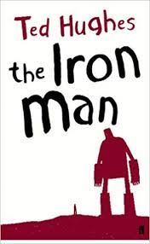

In R.E we will be studying the topic What is Diwali and why is it important?

In French we will be studying the topic Moi!

(All about me)

In ICT we will using our new chrome books.

In PSHCE we will be continuing our visits to the local nursing home and learning about relationships.

In Art we will be making Roman shields and iron men.

Reading

We will be reading The Iron Man by Ted Hughes